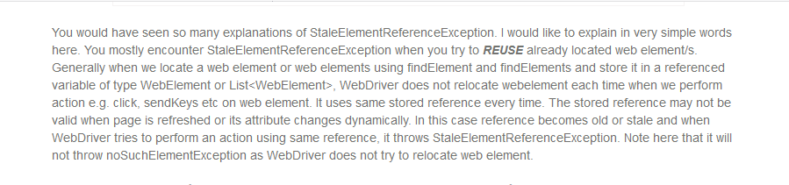

There are two ways of handling stale element reference exception:

First way: By creating the reusable method as follow:

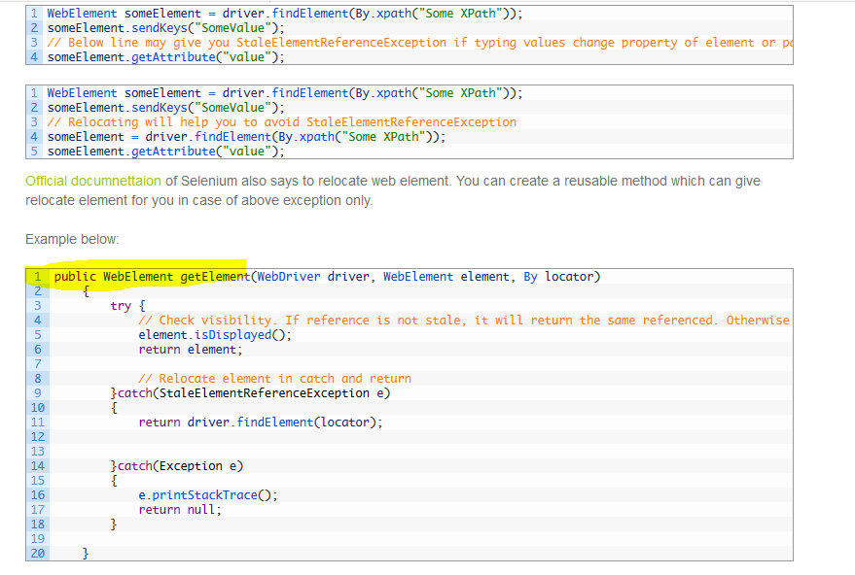

Second way: Through page factory:

